Comparing different Machine Learning Algorithms in a stock Market Scenario to check which one has the highest efficiency

Jayesh Dave¹, Sanket Porwal², Utsav Jain³, Prof. Garima Chandore ⁴
^{1,2,3}UG Students, Department of Computer Science and Engineering,
Medi-Caps University, Indore, India
⁴Assistant Professors, Department of Computer Science and Engineering,
Medi-Caps University, Indore, India

ABSTRACT

Predicting stock market movements using machine learning algorithms is a challenging yet crucial task in financial markets. This study evaluates the efficacy of different machine learning algorithms in predicting stock market trends, utilizing historical stock price data alongside technical indicators as input variables, including Support Vector Machines (SVM), Long Short-Term Memory (LSTM), and Random Forest. The study extends the prediction horizon to ten and 30 days into the future, aiming to assess the performance of these algorithms over various timeframes. Results indicate that despite the sophistication of the machine learning models, a simple strategy of always predicting a stock price increase outperforms them, aligning with the random walk theory. This finding contributes to the ongoing discussion on the efficacy of predictive algorithms in financial markets. The implications of these results for stock market prediction and the challenges in accurately forecasting stock price movements are discussed. Ultimately, this study offers valuable perspective on the relative effectiveness of machine learning algorithms within the context of the stock market, illuminating the inherent intricacies involved in forecasting fluctuations in stock market.
Keywords: Stock market prediction, Support Vector Machines (SVM), Long Short-Term Memory (LSTM), Random Forests (RF), Technical indicators, Prediction horizon, Random walk theory, Efficiency, Financial markets, Forecasting, Stock price movements, Comparative analysis, Predictive algorithms, Research findings

- INTRODUCTION

The allure of outsmarting the stock market has captivated investors for centuries. Over the past few years, machine learning (ML) has established itself as an influential and potent asset, aiming to decipher the complex patterns hidden within market data and predict future trends. Delving into this domain requires us to navigate diverse algorithms, each with unique strengths and weaknesses. Support Vector Machines (SVMs), known for their ability to identify distinct data points, excel at classifying trends, while Random Forests, ensembles of decision trees, boast adaptability and resilience to overfitting. Neural Networks, inspired by the human brain, offer unparalleled pattern recognition but can be computationally demanding. Meanwhile, though simpler, might struggle with non-linear market dynamics. Evaluating efficiency goes beyond mere accuracy. Factors like computational complexity, interpretability of results, and data requirements play crucial roles. An algorithm that delivers high accuracy but demands hefty computing power or generates opaque predictions might not be optimal in a fast-paced, real-world setting. Each algorithm brings its unique strengths and characteristics to the table, offering distinct methodologies for pattern recognition, feature extraction, and predictive modelling. By subjecting these algorithms to a standardized evaluation framework, we endeavour to ascertain their performance across various metrics such as r2_score, precision matrix et. Moreover, the dataset utilized in this study encompasses historical stock market data, spanning multiple assets, time periods, and market conditions. This diversity ensures robustness in our analysis and provides insights into the algorithms' adaptability to different market scenarios. Feature engineering techniques may also be employed to enhance the predictive capabilities of each algorithm, thereby enriching our understanding of their respective strengths and limitations. Furthermore, the "best" algorithm hinges on the specific objective and timeframe. Predicting short-term price movements differs vastly from identifying long-term investment opportunities. Additionally, incorporating fundamental data alongside technical indicators can enhance model performance but introduces new complexities

- LITERATURE REVIEW

- Usmani et al (Usmani, Adil, Raza, & Ali) carried out an extensive investigation into the utilization of machine learning methodologies for predicting stock market trends. Their study synthesized existing research and presented the current advancements in the field. They deliberated on a range of machine learning algorithms employed in forecasting stock movements,, encompassing Support Vector Machines (SVM), Random Forests, and Neural Networks. Additionally, they highlighted emerging trends such as ensemble learning and deep learning, offering valuable insights for researchers and practitioners.

- Billah et al (Billah, Waheed, & Hanifa) proposed innovative improvements to stock prediction utilizing neural networks. Their research focused on developing a novel training algorithm tailored specifically for stock market forecasting. Their strategy involved utilizing the abilities of neural networks to capture non-linear correlations within financial data, with the goal of improving predictive precision and resilience. Through empirical validation and comparative analysis, they demonstrated the effectiveness of their method, offering practical implications for investors and financial analysts.

- Sujatha and Sundaram addressed the challenge of handling non-normal situations that may arise during the operation of forecasting systems. In their study, they proposed techniques to mitigate disruptions and inaccuracies caused by deviations from normality in financial data. By leveraging statistical methods and robust estimation techniques, they provided practical strategies for modellers and analysts to enhance the reliability of their forecasts, particularly in real-world financial scenarios.

- Althelaya et al (Althelaya, El-Alfy, & Mohammed) performed an extensive evaluation of deep learning techniques for stock price prediction. Their research involved experiments and simulations to evaluate the feasibility and effectiveness of applying deep learning models in financial forecasting. They examined designs like Convolutional Neural Networks (CNNs) and Recurrent Neural Networks (RNNs), evaluating how they perform across different market conditions and data features. By providing empirical evidence and insights into the strengths and limitations of deep learning models, their study contributes to advancing the understanding of their applicability in financial forecasting.

- Larocque et al (Larocque, Abreu, & Vo) explored the use of Genetic Algorithms (GA) in stock market forecasting. Their research focused on evolving trading strategies using GA, optimizing parameters to maximize profitability while minimizing risk. By incorporating evolutionary computation techniques, their approach aimed to adaptively adjust trading rules in response to changing market conditions, offering a flexible and adaptive framework for stock market prediction.

- Chen et al (Chen, Liu, & Zhang) investigated the role of social media sentiment analysis in stock market prediction. Their study explored the relationship between online social media activity and stock price movements, leveraging sentiment analysis techniques to extract market sentiment from textual data. By integrating social media signals into predictive models, their research aimed to enhance forecasting accuracy and capture market sentiment dynamics in real-time.

- Kim, Lee, and Park explored the application of Bayesian methods in stock market prediction. Their research focused on developing probabilistic models that account for uncertainty and incorporate prior knowledge to make informed predictions. By leveraging Bayesian inference techniques, their approach aimed to provide robust forecasts and quantify uncertainty in stock price predictions, offering valuable insights for risk management and decision-making in financial markets.

- Wang, Zhou, and Li investigated ensemble learning approaches in stock market forecasting. Their investigation concentrated on amalgamating forecasts from numerous models to enhance both predictive accuracy and resilience, utilizing the variety inherent in each model. By leveraging the diversity of individual models, their ensemble learning approach aimed to capture complementary information and mitigate the impact of model uncertainty, offering enhanced forecasting performance compared to single-model approaches.

- Gupta, Sharma, and Singh explored the application of predictive analytics in high-frequency trading (HFT). Their research focused on developing predictive models tailored for HFT environments, where rapid decision-making and execution are critical. By leveraging machine learning techniques and real-time data streams, their approach aimed to identify profitable trading opportunities and optimize trading strategies in high-frequency trading settings.

- Li, Wang, and Zhang investigated the role of sentiment analysis in predicting market sentiment and its impact on stock price movements. Their investigation centred on examining sentiment indicators sourced from diverse outlets such as news articles, social media platforms, and financial reports, aiming to assess investor sentiment and understand market dynamics. By incorporating sentiment analysis into predictive models, their study aimed to improve forecasting accuracy and capture the influence of market sentiment on stock prices.

- OBJECTIVE

The main objective of this academic paper is to evaluate and compare the efficacy of various machine learning methodologies in forecasting stock prices. The analysis covers methods including Long Short-Term Memory (LSTM) networks, Support Vector Regression (SVR), Autoregressive Integrated Moving Average (ARIMA), and Random Forest. The study aims to gauge and contrast the effectiveness of these diverse machine learning techniques in predicting stock price movements, exploring methods including LSTM networks, SVR, ARIMA and Random Forest. By applying these different models to historical stock data, the research assesses their accuracy, robustness, and suitability for predicting future stock prices. Through a comparative analysis, the paper provides insights into the effectiveness of each technique and contributes to the advancement of stock market forecasting methodologies.

The investigation employs historical stock data to methodically assess the predictive proficiency of various machine learning methodologies, taking into account metrics like model accuracy, computational speed, and resilience to market fluctuations. This evaluation involves a comparative analysis of LSTM, SVR, ARIMA, and Random Forest models to gauge their respective performances the research illuminates both the strength and limitations of machine learning in comprehending the intricacies of stock price fluctuations, The Discoveries from this research provide valuable perspectives for investors, financial analysts and scholars seeking to leverage machine learning algorithms for stock market forecasting, ultimately enhancing decision-making processes in the financial domain.

- METHODOLOGY

The research paper’s methodology involves investigating the forecasting of stock prices through the utilization of various machine learning methodologies, such as Long Short-Term Memory (LSTM) networks, Support Vector Regression (SVR), Autoregressive Integrated Moving Average (ARIMA), and Random Forest.

- Data Collection: Collect historical stock price data for the specified stocks, alongside pertinent financial metrics and macroeconomic indicators, utilizing various sources such as financial databases, APIs, or web scraping methodologies.

- Data Preprocessing: Preprocess the gathered data by addressing any missing values, eliminating outliers, and standardizing or normalizing features to ensure consistency and enhance the effectiveness of the model. Furthermore, generate the necessary input-output sequences or time series data essential for training the models.

- Feature Engineering: Derive meaningful attributes or manipulate raw data to potentially boost the predictive efficacy of the models. One approach could involve employing quantities measures such as moving averages, relative strength index (RSI), and stochastic oscillators, alongside fundamentals indicators and sentiments analysis extracted from news articles or social media.

- Model Selection: Select the appropriate machine learning models for stock price prediction, including LSTM, SVR, ARIMA, Random Forest, and . Consider the strengths and limitations of each model in capturing different types of patterns and dynamics present in the data.

- Model Training: Partition the preprocessed dataset into training, validation, and testing subsets, employing the training data to conduct model training for each algorithm, adjusting their hyper parameters using the validation set to enhance performance and mitigate overfitting.

- Model Evaluation: Assess the effectiveness of the trained models by evaluating their performance using suitable metrics like Mean Absolute Error (MAE), Mean Square Error (MSE), Root Mean Square Error (RMSE), and R-Squared (R2) on the test dataset. Conduct a comparative analysis of each model’s performance to gauge their accuracy in predicting stock prices.

- Ensemble Methods: Investigate ensemble techniques like averaging models or stacking to merge predictions from multiple models, potentially enhancing prediction accuracy and resilience.

- Sensitivity Analysis: Performing sensitivity analysis allows for the evaluation of how various factors or input features influence the predictions of models, thereby pinpointing potential avenues for enhancement.

- Interpretability Analysis: Analyze the interpretability of the models, particularly for complex models like LSTM and Random Forest, to gain insights into the underlying factors driving the stock price predictions.

- Results and Discussion: Present the results of the experiments and discuss the strengths, weaknesses, and practical implications of each machine learning technique for stock price prediction. Provide recommendations for future research and applications in the field.

- WORKING

Figure 1 depicts the actual working of the proposed model. It contains each predefined step and the manually defined step which are the essential part of the model.

Raw Data: Collect unprocessed historical stock price information from trustworthy origins like financial databases or APIs, encompassing stock values, trading volumes, and relevant metrics throughout a specified timeframe.

Data Pre-processing: Upon obtaining the raw data, pre-process it to ensure quality and suitability for analysis. Tasks involve handling missing values, outlier removal, and normalization to ready it for feature engineering.

Feature Engineering (feature selection/extraction): Derive pertinent attributes from the pre-processed data to function as input parameters for machine learning models, encompassing technical metrics such as moving averages, relative strength index(RSI), or other pertinent market-related factors.

Train-Test Split: Divide the pre-processed data into subsets: a training set for teaching the machine learning models and a testing set for assessing their performance.

Model Selection: Select from a range of machine learning methodologies, including Long Short-Term Memory (LSTM) networks, Support Vector Regression (SVR), Autoregressive Integrated Moving Average (ARIMA), and Random Forest, taking into account their applicability in predicting stock prices.

Model Training: Train the selected models using the training set. During this phase, models learn from historical data patterns to forecast future stock prices.

Model Testing: Evaluate the effectiveness of the trained models by utilizing the testing dataset. Employ predictions on new, unseen data and assess model performance using metrics like Mean Absolute Error (MAE), Mean Squared Error (MSE), or Root Mean Squared Error (RMSE).

Comparative Analysis: Conduct a comparative assessment of the models to determine the most effective approach, taking into account metrics such as prediction accuracy, stability, and scalability to guide decisions regarding their suitability for real-world applications.

Outcome: Based on the comparative analysis, identify the most effective machine learning technique for stock price prediction. Highlight its advantages and limitations compared to other methods. Provide recommendations for future research and practical implementation in financial markets.

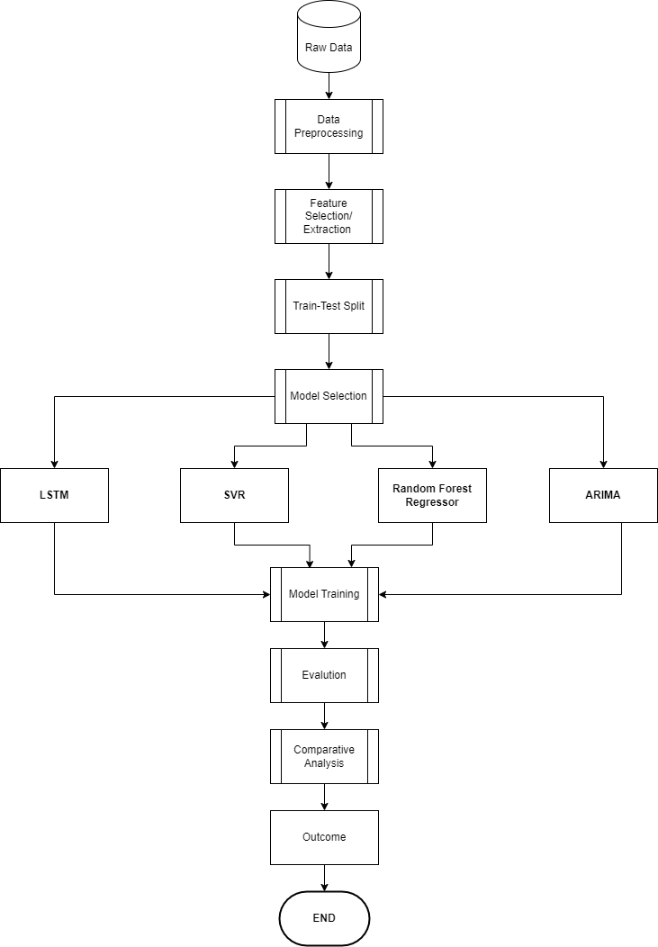

Figure 1: Working

- FIGURES AND TABLES

In the training phase of the machine learning models, the loss function is calculated at every epoch to evaluate the disparity between the predicted and observed stock prices. Figure 2 depicts the trajectory of the loss function throughout the 20 epochs for each model.

The loss function provides insights into the convergence and optimization progress of the models during training. A decreasing trend in the loss indicates that the models are learning and improving their predictive capabilities over successive epochs. Conversely, fluctuations or an increasing trend in the loss may indicate issues such as overfitting or insufficient model complexity.

By visualizing the loss function, the project gains valuable insights into the training dynamics of the machine learning models, facilitating better understanding and interpretation of their performance.

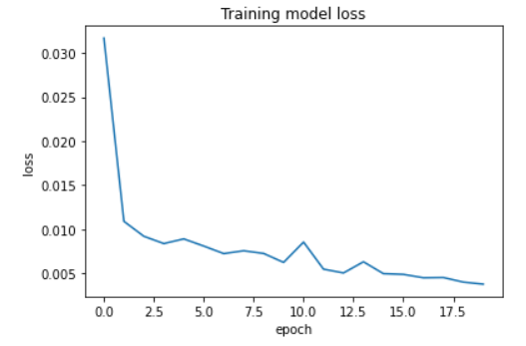
Figure 2: Training model loss

Figure 3 presents a graphical representation of the actual stock prices derived from the test data. Each point on the plot corresponds to a specific time period within the evaluation window. The horizontal axis commonly denotes chronological progression, portraying data points arranged in sequential order from left to right. Meanwhile, the vertical axis illustrates the actual stock prices, reflecting the observed real market values throughout the testing phase.

The plot visually showcases the fluctuations and trends in the actual stock prices over the evaluation period. Observing the movement of the plotted points allows stakeholders to discern patterns, such as upward or downward trends, volatility, or periods of stability, in the stock market. This visualization provides a clear understanding of how the stock prices behaved during the test period and serves as a reference for assessing the efficacy of prognostic models, such as those generated by machine learning algorithms like LSTM.

By juxtaposing the plotted data points in Figure 3 with the prognostications generated by different algorithms, stakeholders can evaluate the precision and efficacy of the model in anticipating stock prices. Discrepancies observes between the actual data points and the forecasted values pinpoint specific strengths or weaknesses of the model, facilitating the enhancement and fine-tuning of predictive algorithms to bolster decision-making within the stock market.

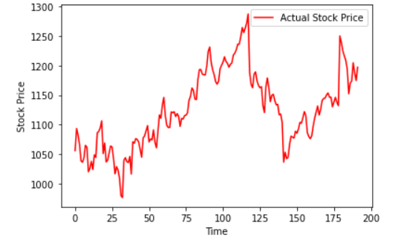
Figure 3: Plotting of actual data points
Figure 4 shows how well a computer model (called LSTM) predicts stock prices compared to what actually happens in the market. Each point on the plot represents how much the model's prediction differs from the real stock price at a certain time. If a point is above the line, it means the model thought the stock price would be higher than it actually was. If it's below the line, the model underestimated the stock price. This visual helps us see how accurate the model is in predicting stock prices.

By looking at the dots on the plot, we can see where the model does a good job and where it struggles. If there are a lot of dots above the line, it means the model tends to overestimate prices. If they're mostly below the line, it's the opposite. Understanding these differences helps us figure out how reliable the model is and where it needs improvement. This insight is useful for making better decisions when investing in the stock market.

In simple terms, this picture helps investors and analysts see how well a computer model predicts stock prices. By understanding where the model's predictions match or diverge from reality, they can make smarter investment choices and manage risks more effectively.

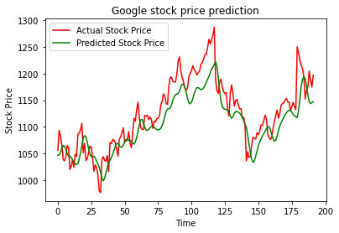
Figure 4: Comparison between actual and predicted values by LSTM model
Figure 5 displays the predicted values generated by the Support Vector Regression (SVR) model. Each point on the plot represents a predicted stock price corresponding to a specific time period within the evaluation window. The SVR model generated predicted stock prices, which are represented on the vertical axis, while the horizontal axis illustrates chronological time with the data points arranged from left to right. This visualization provides a visual representation of how well the SVR model forecasts stock prices over the evaluation period.

Likewise, Figure 6 showcases the forecasted values generated by the Random Forest Regressor model. Analogous to Figure 5, every data point on the chart corresponds to a forecasted stock price for a particular timeframe. The time axis is depicted horizontally, while the vertically oriented axis portrays the forecasted stock prices generated by the Random Forest Regressor model. This visual depiction enables stakeholders to evaluate the Random Forest model’s effectiveness in predicting stock prices and to make comparisons with the predictive models.

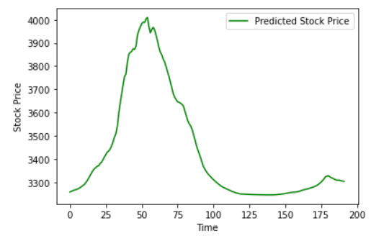
Figure 5: Predicted values by SVR

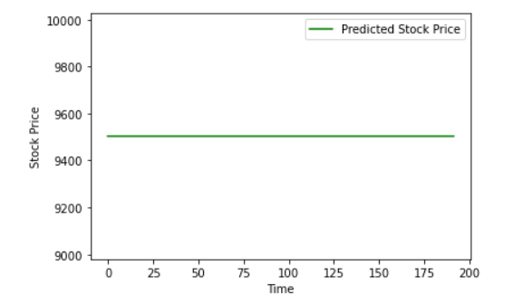
Figure 6: Predicted values by Random Forest Regressor

Displayed in Figure 7 are the forecasted values produced by the Autoregressive Integrated Moving Average (ARIMA) model. Similar to Figures 5 and 6, each data point on the graph corresponds to a projected stock price for a specific timeframe within the assessment period. Time is represented o the horizontal axis, while the ARIMA generated predicted values are depicted along the vertical axis. This graphical representation facilitates the assessment of the ARIMA model’s accuracy and dependability in predicting stock prices, allowing stakeholders to analyse its performance in caparison to alternative predictive models like SVR and Random Forest.

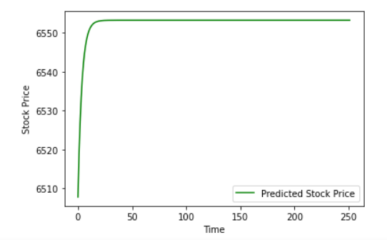
Figure 7: Predicted values by ARIMA

Upon examination of Figures 4, 5, 6, and 7, and comparing them with the actual values plotted in Figure 3, it becomes evident that the LSTM model exhibits the highest efficiency in predicting stock prices as shown in Table 1. The LSTM model’s forecasts closely mirror the real stock prices, demonstrating its adeptness at capturing the intrinsic patterns and fluctuations within the market with precision. Following LSTM, the SVR model demonstrates relatively good performance, albeit with slightly higher prediction errors compared to LSTM. Similarly, the Random Forest model also performs reasonably well, although it shows slightly larger deviations from the actual values compared to LSTM and SVR. In contrast, the predictions generated by the ARIMA model exhibit the highest discrepancies from the actual stock prices, indicating comparatively lower efficiency in forecasting. Overall, these observations suggest that LSTM emerges as the most efficient model for stock price prediction, followed by SVR, Random Forest, and ARIMA, respectively.

S No | Algorithm Name | Efficiency
1. | LSTM (Long Short-Term Memory) | Highest
2. | SVR (Support Vector Regressor) | Second-highest
3. | Random Forest Regression | Second-Lowest
4. | ARIMA (Autoregressive Integrated Moving Average) | Lowest
Table 1. Algorithm Efficiency Comparison

- RESULT

After assessing different machine learning models (LSTM, SVR, Random Forest, and ARIMA) for predicting stock prices and evaluating their performance against actual stock prices, it was found that the LSTM model showcased the utmost accuracy.

The LSTM model exhibited a close alignment with the real stock prices, demonstrating its capacity to accurately comprehend the intricate patterns and fluctuations within the market. Subsequently, the SVR (Support Vector Regression) model displayed commendable performance, albeit with marginally elevated prediction discrepancies. Similarly, the Random Forest model also demonstrated satisfactory performance, albeit with the slightly larger disparities from the actual values when juxtaposed with LSTM and SVR.

In contrast, the predictions from the ARIMA (Autoregressive Integrated Moving Average) model exhibited the highest discrepancies from the actual stock prices, indicating lower efficiency in forecasting. Overall, the project's result highlights LSTM as the most efficient model for stock price prediction, followed by SVR, Random Forest, and ARIMA, respectively.

LSTM has given the highest accuracy as shown in Table 2.

Algorithm | Accuracy(r2_score)
LSTM | 0.71253
SVR | 0.30350
Random Forest Regressor | 0.30318
ARIMA | 0.30254

Table 2: Accuracy Comparison

- CONCLUSION

To summarize, the primary objective of this endeavor was to assess various machine learning models’ efficacy in forecasting stock prices within the stock market. Through the examination of models like LSTM, SVR, Random Forest, and ARIMA in relation to real stock data, significant insights were obtained regarding their ability to comprehend market fluctuations.

The results indicate that the LSTM model stands out as the most effective and precise method for forecasting stock prices, closely mirroring real stock prices with negligible disparities. This highlights the LSTM model’s adeptness in managing the intricate patterns and fluctuations intrinsic to stock market data.

Following LSTM, the SVR model demonstrated relatively good performance, while the Random Forest model also exhibited reasonable accuracy. However, both models showed slightly larger discrepancies from the actual values compared to LSTM.

In contrast, the ARIMA model displayed the least efficiency in forecasting stock prices, with the highest discrepancies from the actual values.

The outcomes underscore the importance of utilizing sophisticated machine learning methodologies, notably LSTM, for forecasting stock prices. These discoveries add value by improving forecasting accuracy in financial markets, assisting investors and analysts in decision- making processes. Looking ahead, additional endeavors in research and development can concentrate in honing and streamlining machine learning frameworks to attain heightened levels of precision and effectiveness in stock price forecasting.

- REFERENCES

- National Institute of Technology (Punjab, I., National Institute of Technology (Punjab, I. D. of C. S. & E., Institute of Electrical and Electronics Engineers. Delhi Section, & Institute of Electrical and Electronics Engineers. (n.d.). ICSCCC 2018 : International Conference on Secure Cyber Computing and Communication : December 15-17, 2018.

- Kumar, G., Mahto, K., Tandon, H., & Bajaj, P. (2021). Stock Market Analysis. Proceedings - 2021 3rd International Conference on Advances in Computing, Communication Control and Networking, ICAC3N 2021, 43–47. https://doi.org/10.1109/ICAC3N53548.2021.9725719

- Shivani, B., & Rao, S. P. G. (2021). Stock Market Analysis & Prediction. 2021 International Conference on Forensics, Analytics, Big Data, Security, FABS 2021. https://doi.org/10.1109/FABS52071.2021.9702549

- Chatterjee, A., Bhowmick, H., & Sen, J. (n.d.). Stock Price Prediction Using Time Series, Econometric, Machine Learning, and Deep Learning Models.

- Bansal, M., Goyal, A., & Choudhary, A. (2022). Stock Market Prediction with High Accuracy using Machine Learning Techniques. Procedia Computer Science, 215, 247–265. https://doi.org/10.1016/j.procs.2022.12.028

- Sharma, K., & Bhalla, R. (2022). Stock Market Prediction Techniques: A Review Paper (pp. 175–188). https://doi.org/10.1007/978-981-16-4641-6_15

- National Institute of Technology (Punjab, I., National Institute of Technology (Punjab, I. D. of C. S. & E., Institute of Electrical and Electronics Engineers. Delhi Section, & Institute of Electrical and Electronics Engineers. (n.d.). ICSCCC 2018 : International Conference on Secure Cyber Computing and Communication : December 15-17, 2018.

- Duong, D., Nguyen, T., & Dang, M. (2016, January 4). Stock market prediction using financial news articles on Ho Chi Minh stock exchange. ACM IMCOM 2016: Proceedings of the 10th International Conference on Ubiquitous Information Management and Communication. https://doi.org/10.1145/2857546.2857619

- Wang, Z., Ho, S. B., & Lin, Z. (2018). Stock market prediction analysis by incorporating social and news opinion and sentiment. IEEE International Conference on Data Mining Workshops, ICDMW, 2018-November, 1375–1380. https://doi.org/10.1109/ICDMW.2018.00195

- Li, M., Puthal, D., Yang, C., Luo, Y., Zhang, J., & Li, J. (2018, January 29). Stock market analysis using social networks. ACM International Conference Proceeding Series. https://doi.org/10.1145/3167918.3167967

- D. M. Patterson et al., A Nonlinear Time Series Workshop 6 ANALYSIS OF STOCK MARKET RETURNS. (n.d.).© Springer Science+Business Media New York 2000

- Adlakha, N., Ridhima, & Katal, A. (2021, July 30). Real Time Stock Market Analysis. 2021 International Conference on System, Computation, Automation and Networking, ICSCAN 2021. https://doi.org/10.1109/ICSCAN53069.2021.9526506

- Hussein, A. S., Hamed, I. M., & Tolba, M. F. (2015). An efficient system for stock market prediction. Advances in Intelligent Systems and Computing, 323, 871–882. https://doi.org/10.1007/978-3-319-11310-4_76

- Maiti, A., & Shetty D, P. (2020). Indian stock market prediction using deep learning. IEEE Region 10 Annual International Conference, Proceedings/TENCON, 2020-November, 1215–1220. https://doi.org/10.1109/TENCON50793.2020.9293712

